***CBRE Challenge Presentation***

Submitted by:

Falak Naaz - FXN210012

CBRE is the #1 commercial real estate firm in the world. Your challenge is to create a prototype intended to improve the “site selection” process in commercial real estate – which is the process of selecting a plot of land or existing building/structure to develop for business purposes. Utilise AI/ML to help CBRE confidently identify the location of its next commercial development endeavour. Factors that are considered, when choosing the best possible site are 1) target audience, 2) demographics (location, zoning, labor analytics, etc.) and 3) historically profitable locations/markets. Please use the data here: [<https://cbre.ent.box.com/s/i8all613pbe71bex02e4jecsxuhr4d6d>]

STEP 1: Data cleaning

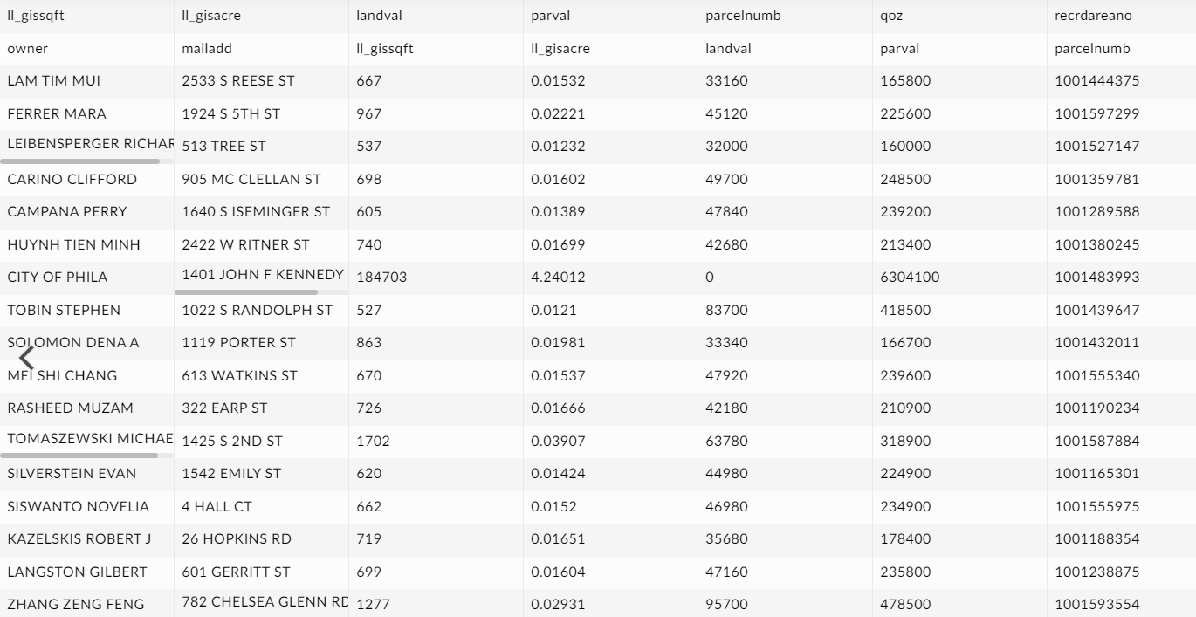

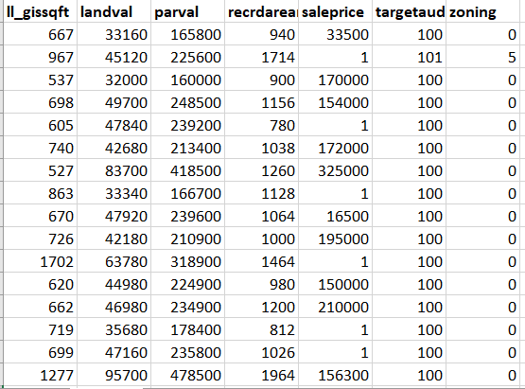

STEP 2: Finding the best model for the given dataset

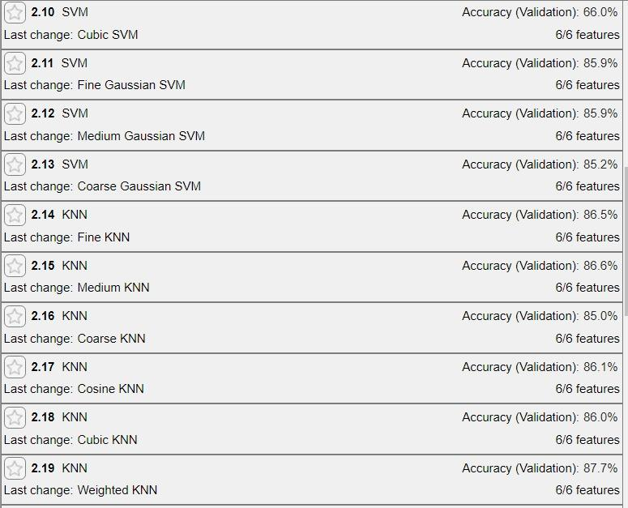

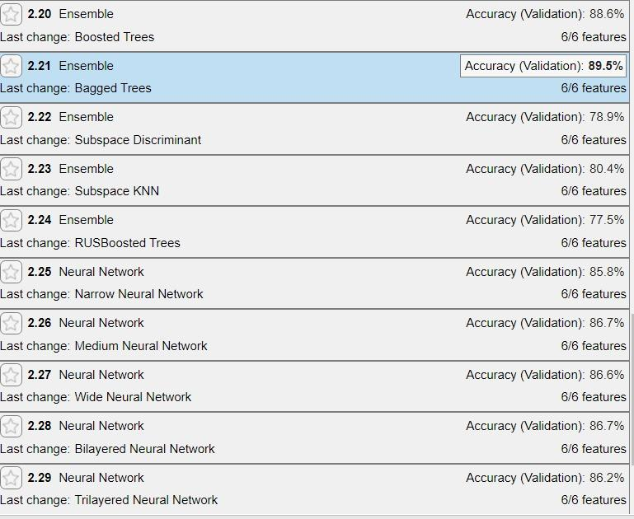

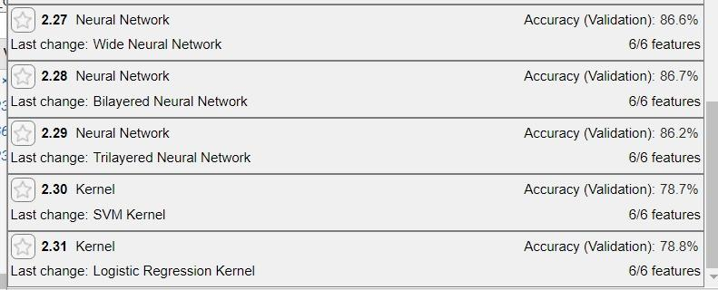

STEP 3: OPTIMIZE THE BEST MODEL OBTAINED - Ensemble bagged trees

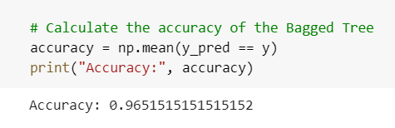

STEP 4: TESTING THE MODEL USING A TEST INPUT

